# Selecting the right Plastic Tooling Partner for Product Development

# Introduction

Innovation begins with the problem and the needs of society. The plastic product development team identifies those problem and their solutions. They list down the features needed and design the product that solves the identified problem. The design involves the features and the concept of the overall product in virtual. Their mission requires the right tooling partner who can convert their idea into reality. These tooling partners play a main role in the development of the plastic products that we use in our daily lives. This article excavates the importance of choosing the best tooling partner for your plastic product development business. It also involves key considerations and strategies to shortlist and choose the partner appropriate for your project. It also explores the symbiotic relationship between product development and plastic tooling.



Figure 1 Partnership between product development and plastic tooling

# Conceptualizing Product Development

For any product development, the first need is the vision of a product that solves the identified problem. The innovation begins with this vision which we term as “conceptualization” or simply as “concept”. Conceptualization is the base of product development that illustrates the product’s purpose, functionality, and design. This is the step that saves you lot of money and time later by defining the product's technical specifications and functional requirements at the initial stage of product development.

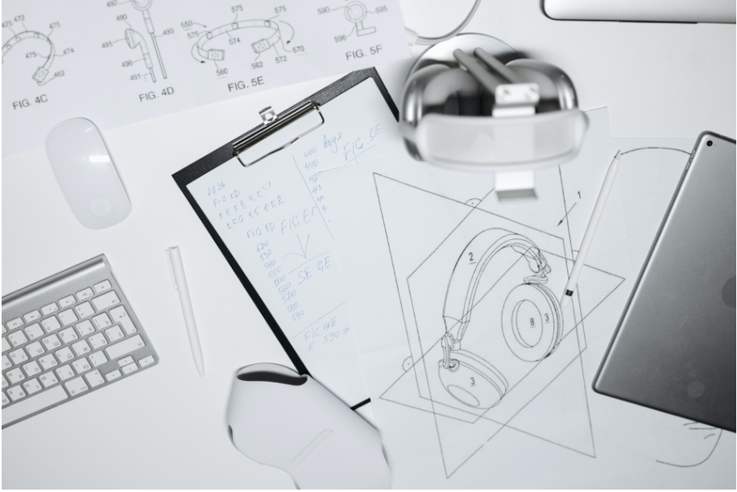

Figure 2 Conceptual drawing of the product (source:https://www.schedioscientific.com/service/product-design-and-development

It is essential to understand the problem that your product aims to solve as well as the demand and preferences of the potential users in initial stages of product development. Basically, It also includes research, market surveys, target audiences, design specifications, and product limitations. You should have an overview of your product virtually by the means of any CAD software or technical drawing by the end of this phase.

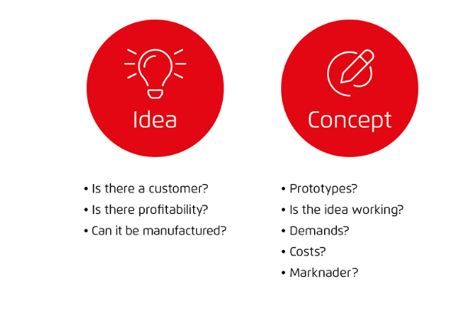

Figure 3 Idea and concept phase

Your product must answer these questions above before finding the tooling partner for your project. Your concept idea must be working and meet the demands with the cost-effective solution. Your idea must be profitable and should be manufacturable. It is very important to have a clear concept and design specifications. This design information needs to be recorded in a document. The next step is to identify a potential partner with plastic tooling expertise who can transform your document’s information into a beautiful product.

# Identifying Potential Plastic Tooling Partners

The key part of selecting partners for plastics tooling lies in identifying those who will transform your design into a real product. They are the one who is responsible for your product’s overall quality and finish. Research for shortlisting potential partners is mandatory before selecting the right one for your product. Careful consideration and research in this stage is very important for choosing the tooling partner. You might filter the wrong partners and miss the appropriate partners if you misconduct the research. Here are the strategies and considerations to help you with shortlisting potential tooling partners for your business:

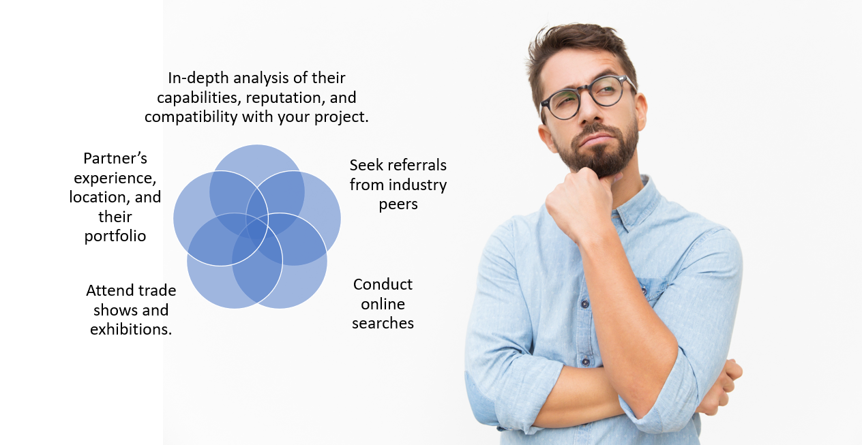

Figure 4 Strategies to shortlist right tooling partner

The right tool partner will definitely have expertise and capabilities that meets your project needs. It is important to choose the partner according to their compatibility with your project for the best outcome. Partner’s location also plays a crucial role. You will definitely need to prefer the partner with the closest location. You need to choose a partner with advanced precision manufacturing technology if your project requires high-quality parts. If you require parts in huge numbers then you need to seek a manufacturer who has the capability to parts in huge numbers. The selection is generally based on your project scope and requirements.

# Assessing Technical Proficiency and Expertise

It is essential to look at their technical capabilities and expertise such that you know what they bring to the table while selecting the tooling partner. They are the people that either make or break your project. It is very important to understand their technical competence and knowledge. You should have background information in terms of their ability to provide accurate solutions. Priority should be high for the tooling partner who has a team of engineers with skills and experience of years. Here are some criteria to evaluate the technical skills and expertise of tooling partners:

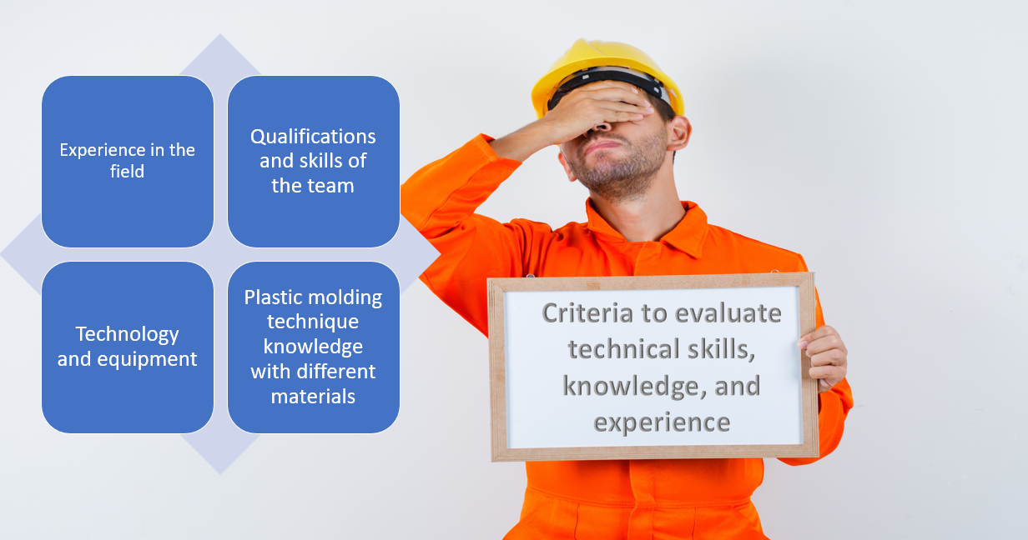

Figure 5 criteria to evaluate technical skills, knowledge, and experience

It is also important to understand their ability to handle some specific requirements. You may need to use special material or composite for particular parts. You may also need to make some changes and adjust the design at the last moment which may form complex geometries. You need a partner who can handle these specific requirements and challenges without crossing the deadline and the budget

# Evaluating Design Support and Prototyping Abilities

Your tooling partner should suggest a better option to refine your product’s functionality and manufacturability. Their design support and prototyping abilities impact your overall project. Your partner should have substantial knowledge of design for manufacturing and prototyping and can suggest to optimize your design for better results. Your partner should also be able to save your time and resources with cost-effective solutions.



Figure 6 design support by tooling partner

# Quality Control and Standards Adherence

Quality and adherence to industry standards are the two things that are non-negotiable for any product development. The evaluation of the potential partner’s ability to maintain industry standards with high-quality parts and their quality assurance processes is the must thing to do.

Quality control is process to ensure that your product meets the required standards. The inquiry about their quality control processes must be done while choosing the right partner for your business. It is also necessary to know how they inspect and test the molds or the tools they create. A reputable tooling partner will focus on maintaining the standards for the product such that there is no legal issue. These evaluations will give you a brief overview of how your product will meet your expectations and the industry standards.

# Analyzing Collaboration and Communication

Collaboration and communication with your tooling partner are essential for the success of your product development journey. Imagine your partner doesn’t listen to your feedback and requests on specific needs. Imagine that they don’t provide any updates about the ongoing process with your product and also exceed your expected budget. The result will be terrible with many misunderstandings and disappointments. So, effective collaboration and communication is the key to ensure that you and your tooling partner are aligned with similar vision, goals, and timelines.



Figure 7 Effective collaboration and communication

Clear and consistent communication must be done for development of any product. It is crucial that the tooling partner provides you the regular updates showing on going process and addresses any concerns that may arise. The issue can be mutually solved with the effective communication between product development and partner by allocating more resources or time. Your partner should not be just an expert but also an open minded to hear your feedback and concerns. They also must be ready to adapt and adjust to changing requirements. The collaboration and communication is a two -way thing. The product development team also must consider what the tooling partner has to say. This creates a healthy environment of relationship that lead to effective collaboration and communication ultimately leading to successful completion of project.

# Reviewing Portfolio and Client Testimonials

A good tooling partner must have good portfolio of similar projects and proven history by previous clients. This gives you an oversight of the quality of their work and what other clients felt about the work that they delivered. It is essential to review your potential partner’s portfolio and client feedback for them to learn about their capability and reliability of handling the project. This evaluation also helps you to track the record of the project completion with other clients. This evaluation is crucial for you to build your trust and confidence on your partner.

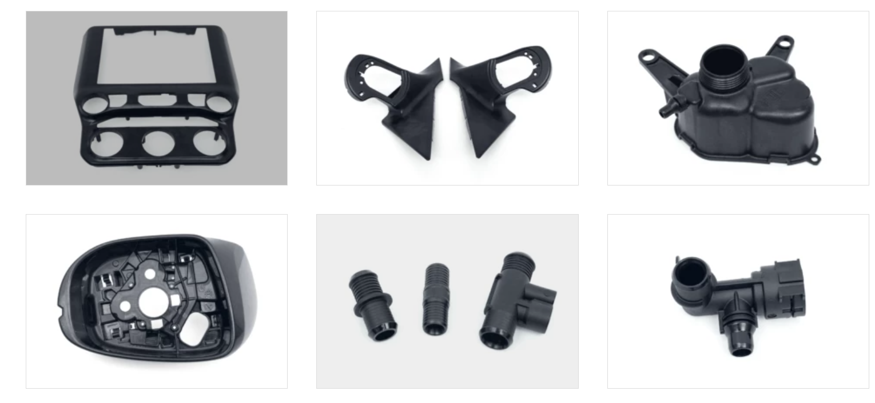

Figure 8 Portfolio of TDL company on producing automobile parts

A portfolio is a beautiful wall of past work and the ability to deliver similar quality. You can make a judgment of their capability and their working diversity through their portfolio insights. Reviewing their portfolios allows you to assess the quality they deliver and what to expect of them. It also demonstrates their ability to meet deadlines and budgets. A partner who has done similar projects before should be high on your priority list for potential partner.

Client testimonials are the reviews that provide answers of the ability to meet the client's expectations and needs. A happy client will definitely leave feedback on either the website or other platforms. You should do online searches and speak with past clients if possible. These give you an overall explanation of how they handle your project.

# Negotiating Terms and Finalizing Partnership

The final step is negotiating terms and finalizing partnership after all the evaluation is done and you come down to final candidate. It is necessary to have clear contract terms to ensure mutual understanding for a successful partnership. The contract ensures that both parties understand the project goals and work to be done. Contract also ensures that you partner is committed to delivering successful completion.

Here are the negotiation strategies and considerations for you before finalizing the partnership:

* Discussion of project details
* Discussion on the allocated budget and other resources
* Discussion on milestones with a clear roadmap
* Agreement on quality control process and to meet industry standards
* Determine ownership of the right to property
* Discuss plans for unexpected challenges
* Signing a contract with all agreements

A contract is a must thing to be built and signed by both parties that they both agree to the terms mentioned. The contracts should basically contain all the agreements like project deadlines, specifications, budget, payment terms, and actions for any unexpected challenges. The contract should be made carefully to ensure security in case of dispute between both parties. The contract is the final step of finalizing a partnership with your right tooling partner.



Figure 9 finalizing partnership with contract (source: https://www.freepik.com/free-photo/two-men-shaking-hands_3469428.htm#query=contract&position=10&from_view=search&track=sph)

# Conclusion

Plastic tooling partner plays the role of bringing your plastic product idea to the product that we can touch. Their contribution to the product development is like hand to the brain. Their selection is a tough decision that should be made on the various criteria evaluation. You need to develop a concept of a product with design specifications that solve the problem and fulfill the demand of the customers before heading to search for tooling partner. The first step in selecting the right plastic tooling partner for your project involves identifying potential partners that match your product background. The considerations involve their ability to assess technical proficiency and design support for your product. They should be able to use their expertise to enhance your design and use appropriate manufacturing technology to deliver the project within budget and timeline. The evaluations need to be done on their ability to produce quality parts with proper quality control and maintaining the industry standards. Effective collaboration and communication bring the best out of each other and the successful completion of the project. So, choosing a partner who can provide you regular updates and adapt to the requested changes is essential. Also, the best way to identify your partner’s reliability is to review your partner’s portfolio and client testimonials. This gives you an oversight of the overall quality of your product and what to expect of your tooling partner.

Once you complete shortlisting to selecting a final partner, then the final agreement is needed to officially start a partnership. A well-drafted contract finalizes the mutual agreement and partnership officially. A successful partnership and symbiotic relationship is built with effective communication and collaboration from both parties which ultimately leads to innovation that transforms society.